Sample Proceedings Paper: Instructions for Preparing ICA2009 Papers

Author Surname1*, Author Surname2* and Author Surname3#
∗ Bandung Institute of Technology
Jalan Ganesha 10, Bandung 40132, Indonesia
E-mail: ica2009@tf.itb.ac.id
# Bandung Institute of Technology
Jalan Ganesha 10, Bandung 40132, Indonesia
E-mail: Inter.ica2009@gmail.com

Abstract
This is an example for ICA 2009 Proceedings papers. Use a two-column format in A4 paper (210297mm). The title and author information should be centered across both columns on the first page. Dimensions for the paper are specified as the following: Text height (245mm), Text width (174), column width (83 mm), Columnsep (8mm), Oddsidemargin (18mm), Top margin (28mm), Bottom margin (24mm). Your paper should begin with an abstract of about 100-150 words.
1 Introduction
The ICA 2009 Proceedings will be published in CD-ROM, and the final program printed in hard copy with paper abstracts and index. No changes will be possible after submission of your manuscript. To maintain uniformity of the Proceedings and the program, please adhere to guidelines in the style file of Microsoft Word or LaTex.
2 General Instructions
Each paper is allocated up to 6 (six) pages including figures. The PDF files will appear on the CD-ROM directly as received. Do not print the page number.
3 Style Guidelines
All manuscripts must be single-spaced, in the specified two-column format. The font size should be 10 points. The citation style uses bracket number, for example [1], [1,2] or [1-5]. For three authors and more, the style refers to [3].
Use the following format for equations
$x(i+1)=f(x(i)+G(x(i), u(i))θ(i)$ (1)
$y(i)=\sum_{j=0}^{i}{c_{j}}h(x(j))$ (2)
where equations should be numbered consecutively throughout the text and referred as Equation (1) or (2) in the text. Figures and tables should also be numbered with appropriate captions below figures and above tables.
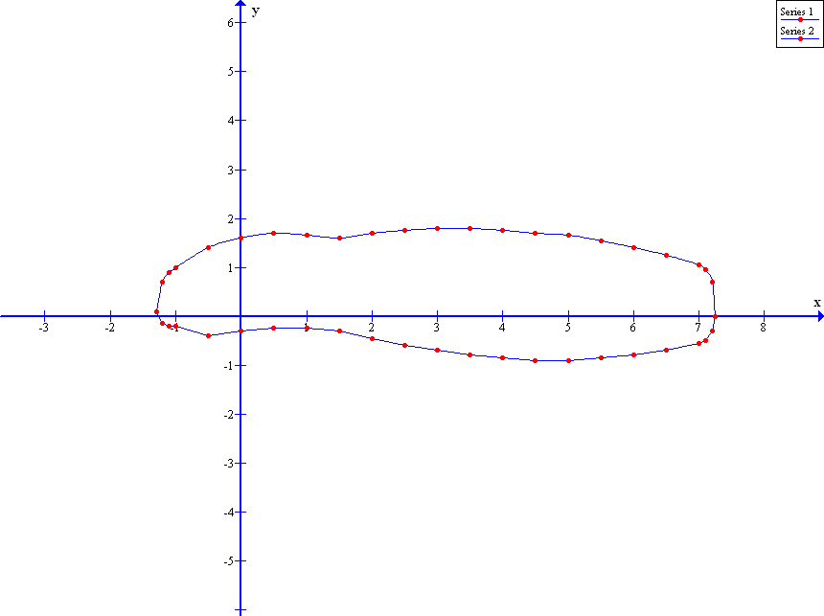
Figure 1: X-Y plane
4 Conclusions
All manuscripts must be received by the publishing house no later than October 1st 2009, in order to be included in the conference CD-ROM and the final program. The authors should also send The Copyright Form to the ICA 2009 secretariat.
References
- A. Author 1, “Article number one”, Automatica, 29 (10), pp.xxxx-xxxx, 19xx.
- B. Author 2 and C. Author 3, “Article number two”, Proceedings of the 36th IEEE Conference on Decision and Control, Tampa-Florida, USA, pp.xx-xx, 1998.
- D. Author4, et. al., Book number one, Prentice Hall Inc., New York, USA, 2009.
- E. Author5, “InBook number one”, in Book number two, (Eds.: F. Author6 and G. Author7), Springer, Berlin, Germany, pp. xxxx-xxxx, 2009.
- H. Author8, “Thesis title one”, PhD Thesis, The Australian National University, Canberra, Australia, 2009.

