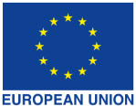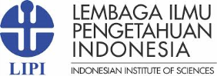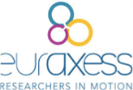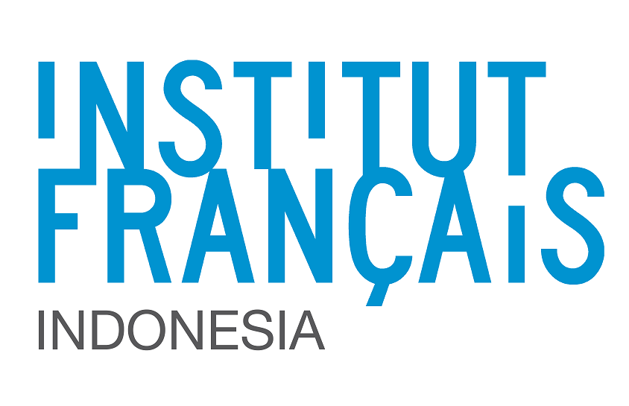

Seminar on Europe Union (EU) and Indonesia
Research and Innovation Cooperation
A joint initiative of:
Indonesian Institute of Sciences (LIPI)
EU Delegation to Indonesia and Brunei Darussalam
European Union Member States
EURAXESS
21 March 2017, Auditorium of IFI, Jakarta, 13:00-17:00

Background
Science and Technology and research collaboration forms an integral part of the European Union (EU) -Indonesia partnerships. Acknowledging the expansion of Indonesia's potential for research and innovation, the EU and its Member States encourage Indonesian researchers and innovators to participate in collaborative projects with Europeans. It is our clear ambition to further strengthen these ties and to engage together in science, research and innovation for mutual benefit.

Indonesian institutions and individuals are eligible to participate in numerous EU and national EU Member State programmes. In particular, the current EU Framework Programme for Research & Innovation "Horizon 2020" and other research funding opportunities offered by the EU Members States, give hope for future and tightened cooperation in the fields of science, research and innovation between the EU and Indonesia. This offers enormous prospects and benefits for Indonesian stakeholders who are invited to take full advantage of the opportunities offered.

Objective
The objectives of this half-day seminar on EU-Indonesia research and innovation cooperation are:
- To look ahead together on how to strengthen research cooperation between the EU and Indonesia.
- To disseminate information on research funding opportunities available for Indonesian researchers and institutions, how to access these funding opportunities and the requirements for applications.
We have great expectation regarding the Seminar and are convinced that fruitful results will emerge for promising collaborations.

Language of instruction: English

Seminar Participants
- The seminar is open for all staff and lecturers of higher education institutions / universities, research and other relevant institutions who are actively involved in international cooperation and university partnerships in the field of research.
- Participants must possess a good level of English since the seminar will be conducted in English.
- This seminar it is not targeted towards students and it will not conduct presentations on student scholarships.

Date
Tuesday, 21 March 2017, 13:00-17:00

Venue
Auditorium of Institut Français Indonesia (IFI) – Insitut Perancis di Indonesia
Embassy of France
Jl. M. H. Thamrin no 20
Jakarta Pusat 10350
Tel.: (62-21) 23 55 79 00

Costs
- Free of charge.
- Participants must cover their own travel and/or accommodation costs.

Participant Registration
- Prior registration is mandatory.
- All participants should register here: https://eeas.europa.eu/delegations/indonesia/21875/seminar-eu-indonesia-research-and-innovation-cooperation_en
- Only participants receiving positive email confirmation from Eventbrite will be accepted into the seminar.

Additional information

European Union (EU)
The European Union (EU) is a unique grouping of 28 independent countries with around 510.1 million citizens living within its boundaries. The 28 EU Member States consist of: Austria, Belgium, Bulgaria, Croatia, Cyprus, Czech Republic, Denmark, Estonia, Finland, France, Germany, Greece, Hungary, Ireland, Italy, Latvia, Lithuania, Luxembourg, Malta, Netherlands, Poland, Portugal, Romania, Slovakia, Slovenia, Spain, Sweden and the United Kingdom.

European Research Council
The year 2017 will mark the 10th anniversary of the European Research Council (ERC) which was set-up by the European Commission in 2007. In ten years only, the ERC has become a brand of scientific excellence and a recognised success story for the European Union: thousands of research leaders and teams supported, 90.000 articles featuring ERC projects in scientific journals, hundreds of breakthroughs and discoveries that are opening new horizons to tackle medical, industrial, societal challenges and so on. Ten years of success deserve to be celebrated and widely communicated, also to show to the scientific community, the importance and added value of what Europe is doing in the field of research. The commemoration of th ERC 10th anniversary will take place in many European countries in March 2017.

Organising Committee
The European Union Delegation of the European Union to Indonesia and Brunei Darussalam
Intiland Tower, 16th floor, Jl Jend Sudirman 32
Jakarta 10220 Indonesia
Tel: (62 21) 2554 6245

Seminar on Europe Union and Indonesia Research and Innovation Cooperation
Time | Description
13:00 – 13:30 | Registration of participants
13:30 – 13:45 | Opening Remarks  - Welcome remarks by an official of the Delegation of the European Union (EU) to Indonesia and Brunei Darussalam  - Welcome remarks by an official of the Indonesian Institute of Sciences (LIPI)
13:45 – 14:00 | Key note speech from the Indonesian Institute of Sciences (LIPI)
14:00 – 15:00 | National collaborative schemes for scientific & research cooperation with Indonesia by the European Union (EU) Member States  - France: Prof Dr Nicolas Gascoin, S&T Counsellor, Embassy of France.  - Germany: Dr. Svann Langguth, S&T Counsellor, Embassy of Germany.  - Spain: Mr. Alfonso Gamero, Representative of CDTI (Spanish Innovation Agency) in Indonesia  - United Kingdom: Ms Anissa. S. Febrina, Research & Innovation Programme Manager, British Embassy Jakarta
15:00-15:15 | Discussions, Questions and Answers
15:15 - 15:30 | Coffee/tea break
15:30 – 15:50 | Opportunities for EU Indonesia Collaboration under Horizon 2020  Mr Raffaelo Quarto, Head of Trade Section, the Delegation of the European Union to Indonesia and Brunei Darussalam
15:50 – 16:05 | A sharing session: advantages of collaborating with Europe, tips on how to succeed, achievements after the EU grant has finished.  - Prof Tatas Brotosudarmo, Director and Principal Investigator, Ma Chung Research Center for Photosynthetic Pigments, Universitas Ma Chung. Marie Curie Fellow and co-founder of the Southeast Asia chapter of the Marie Curie Alumni Association  - Prof Leenawaty Limantara, Rector, Universitas Pembangunan Jaya - Humboldt Fellow
16:05 – 16:20 | 10th Anniversary of the European Research Council: opportunities for excellent scientists  - Ms Alexandra Lehmann, Attaché, EU Delegation to Indonesia and Brunei Darussalam  - Mr Simon Grimley - Regional Representative
16:20 – 16:35 | EURAXESS - Researchers in Motion  Mr Simon Grimley - Regional Representative
16:35 – 17:00 | Discussions, Questions and Answers
17:00 | Closing

