▣ **Information Sheet for Academic Year 2016**

For bilateral exchange students

(Last update: August 27, 2015)

**Chonnam National University**

• (General) http://www.jnu.ac.kr (OIA) http://international.jnu.ac.kr

▣ **Contact details**

|  |  |  |  |
| --- | --- | --- | --- |
|  | Name | Phone | Email Address |
| *Dean and V.P.* | Prof. Dr. OH Kyung-Taek | +82 62 530 1130 | ktoh@chonnam.ac.kr |
| *US/Canada/Australia* | Ms. KANG Shinhye | +82 62 530 1273 | shannon@chonnam.ac.kr |
| *China Exchange* | Ms. SHIN Juhyun | +82 62 530 1275 | aini77@chonnam.ac.kr |
| *Europe/Africa Exchange* | Ms. CHA Eunhui | +82 62 530 1270 | Chacha1052@chonnam.ac.kr |
| *Japan Exchange* | Ms. PARK Eunjee | +82 62 530 1267 | eunjee@chonnam.ac.kr |
| *Asia Exchange* | Ms. JEON Beyl | +82 62 530 1272 | jeonbeyl@chonnam.ac.kr |
| *Fax:* | +82 62 530 1269 | | |
| *Mailing Address:* | Responsible coordinator (see above)  Office of International Affairs  Chonnam National University  77 Yongbong-ro, Buk-gu, Gwangju 500-757, South Korea | | |

▣ **Application process**

All incoming international students are required to fill out the CNU application form. Please attach all the required documents below to your printed application form, make it one “scanned” copy (in colors), and send it to your coordinator at CNU “by email” before the deadline. The scanned file should be sent by the home institution’s outgoing students’ coordinator. ***The applications are not necessary to be sent by post. Scanned file of it is okay with us to speed up the issuance of documents for visa.***

(Required documents)

1. **Application form** (Sheet #1-5) Printed form after filling them out (by typewritten)  
   - *A photo: head shot picture with a white background showing your ears* is required for

international safety and identification purposes.  
- A hand-written signature is required at the bottom of the medical self-assessment.

- The type-written essay should be a minimum length of 500 words and a maximum of 800.

1. **Official Transcript** of Records “in English” (issued by the applicant’s home institution)
2. One (1) **Letter of Recommendation**

* Preferably from a professor
* Invalid if recommendations are made by family members or friends

1. One (1) Copy of the photo page of the **student’s passport**
2. A confirmation of **English language skills** (language certificate or confirmation from home institution)

▣ **Dormitory & course Registration**

|  |  |
| --- | --- |
| ***Application***  ***Deadlines*** | Application for Fall semester: **April 30th**  Application for Spring semester: **October 30th** |
| **Application deadlines apply to the dates when a scanned copy of the student’s application reaches the Office of International Affairs of CNU. | |
| ***Dormitory***  ***Registration*** | Spring semester: **January 2016**  Fall semester: **July 2016** |
| ** Once a student’s application reaches OIA CNU, their on-campus dormitory room is “automatically” reserved. It is not necessary to send a housing request form to us. During the above mentioned period, OIA CNU staff will register on behalf of international students. | |
| ***Course***  ***Pre-registration*** | Fall semester**: 1ST week of August**  Spring semester: **1ST week of February** |
| ** OIA CNU will send the list of courses offered in English and course registration form to the students in order to pre-register for courses. Every first week of the semester, we have “course add & drop” period, so you can change, add, or drop courses after your arrival at CNU. A student’s course registration will be finalized after this period. | |

▣ **Academic calendar**

|  |  |  |
| --- | --- | --- |
|  | *Spring semester 2016* | *Fall semester 2016* |
| *Official Arrival Date* | February 29, 2016 | August 30, 2016 |
| *Class Begin* | March 2, 2016 | September 1, 2016 |
| *Orientation Week &*  *Formal Registration at CNU* | First week of each semester | |
| *Mid-term Examination* | April 18-22, 2016 | October 19-23, 2016 |
| *Class End* | June 10 | December 11,2016 |
| *Final Examination* | June 13-17, 2016 | December 14-18,2016 |
| *Official move-out (dormitory)* | June 18, 2016 | December 19, 2016 |

*On the first week of each semester, exchange students are required to visit the Gwangju Immigration Office to apply for your “**Alien Registration Card**”. The card will be used as ID (or kind of residence permit in Europe) during your stay here in South Korea. It usually takes 3 weeks to have it issued.

▣ **Visa requirements:**

The regulations for obtaining visas change from time to time. Successful applicants will receive a “Certificate of Admission” from CNU. Students are required to apply for a Student Visa (D-2) at Korean embassy/consulate located in their home country. As processing of a visa takes several weeks, it is highly advisable to apply for it immediately when you receive the document.

▣ **Health insurance:**

We recommend that incoming students purchase a health travel insurance plan in their home country. If they already have insurance from their home country, they are advised to bring proof of coverage when they come to CNU. Alternatively, students may purchase the insurance in Korea; full coverage for international students costs around 170,000 KRW (USD 150.00) for a year and 100,000 KRW (USD 90.00) for a semester.

▣ **Accommodation information:**

|  |  |
| --- | --- |
| Building | Room Type and Fee |
| Dorm 9 | Short-term: 527,250 KRW (502 USD) room charge(semester)  Long-term: 749,350 KRW (685 USD) room charge(semester + vacation) |
| Type of housing: 6 people suite  *apartment style with 3 rooms, two people share one room |
| - Twin Beds in a room / Shared-bathroom & shower room in an apartment  - Wired Internet access available  *IP will be given to each room. Students need to purchase a LAN cable to get access to the Internet. |
| * Some exchange students shall receive room without any charges according to the agreement between two institutions.  *C:\Users\user\Desktop\BTL.jpg*\*\* Exchange students need to pay the accommodation fee in cash within 7 days after your arrival at CNU to the Office of International Affairs. | |

▣ **Intensive Korean language courses during regular semesters:**

Intensive Korean language courses are offered by the on-campus CNU Language Education Center during the academic year for incoming exchange students for free of charge.

Dates of sessions: **14 weeks** after a semester starts

Class time: two hours every Tuesday and Thursday (Day of the week can be changed.)

Level of instruction offered: **all levels**

▣ **Services available to exchange students:**

• **Pick-up service** from Incheon International Airport (ICN)

*only available during the official arrival dates(and the date can be changed)

At the Exit D, CNU students will guide new incoming exchange students to take limousine buses to get to CNU in Gwangju. The ***bus ticket costs 50,000 KRW*** (50.00 USD), and it should be paid in cash. It will take about 4 hours to get to the dormitory on campus. When you arrive at CNU, CNU buddies will help you move into the CNU dormitory! ☺

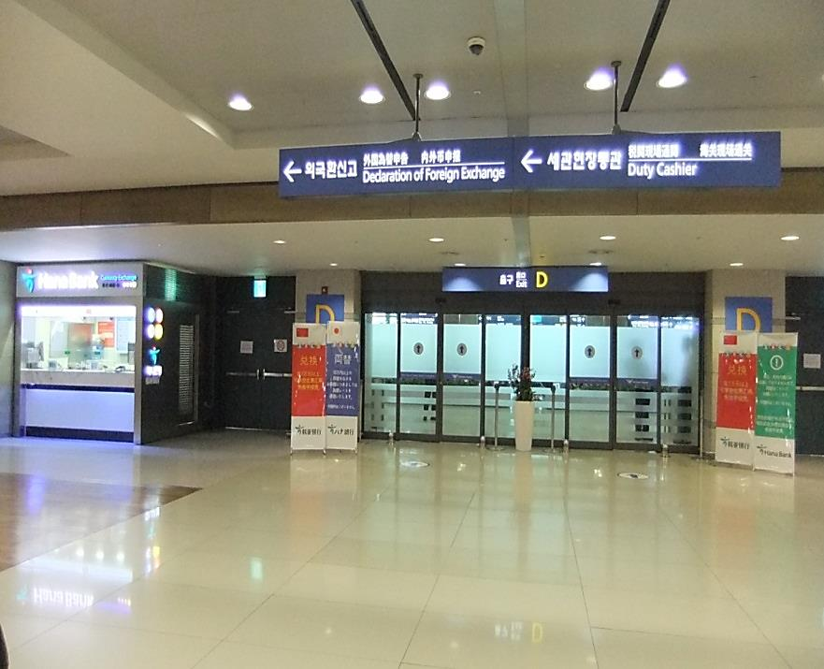

Please look for the Exit D to meet.

• Student buddies  
CNU is offering buddy matching program that connects inbound exchange students and CNU students on a one-to-one basis. CNU students (buddy mentors) provide the helping hand and friendship to the new comers at CNU.

• Welcome & Farewell party

• Social activities, e.g. get-togethers and trips

▣ **Academic notes**

Students’ home institutions set the policy regarding the award of credit for coursework completed at CNU. Students are responsible for knowing your home institution’s policies and procedures regarding this matter.

Academic information useful to participants: CNU subscribes to the system of Korean CREDIT. CNU does require exchange students to take at least 9 Korean credits (about 18 ECTS) a semester. A course of CNU usually grants 3 credits. (Workloads /Course = 3 hours a week, total 45 hours a semester)

* ***Minimum*** Korean CREDIT workloads to keep CNU student status: 9 credits per semester
* ***Maximum*** Korean CREDIT exchange students can take: 18 credits per semester

1. **Language of instruction:** Korean/English

**CNU offers about 150 courses taught in English, mainly from the College of Business Administration.

1. **Grading system:** 95-100 = “excellent”

90-94 = “very good”

85-89 = “good”

80-84 = “highly satisfactory”

75-79 = “satisfactory”

70-74 = “fare” / “sufficient” (minimum passing grade)

00-69 = “insufficient”

It is unfortunately impossible to issue attachments with estimated equivalent evaluation used at the host university. Herewith, it is advisable to make sure there is a policy at home university that it enables student to covert the Korean CREDIT grades into the evaluation in use there. However, upon request, abstracts and syllabi of the courses student complete during their stay can be issued and attached to the transcript of record.

▣ **Transcript issuance:**

***Spring semester 2016***: by the last week of July

***Fall semester 2016:*** by the last week of January 2017

The transcript of records will be sent by the OIA CNU to the students’ home institutions by post after the exchange students’ returning to home.

▣ **Estimated personal expenses per month:**

|  |  |
| --- | --- |
| *Food (per meal)* | 2-6 USD |
| *Fee for dormitory*  *& Alien Registration Card* | • dormitory fee & meal plan: 500,000KRW(476USD) ~1,300,000 KRW(1,238USD)/vary with the type  • issuance of Alien card: 30,000 KRW (29.00 USD) |
| *Health insurance* | • a year: 150.00 USD  • a semester: 90.00 USD |
| *Local Transportation* | • bus fare (one-way) : 1.00 USD  • taxi fare: You can reach everywhere in Gwangju within 15.00 USD  (eg. Gwanju Bus Terminal to CNU: 5 USD, Gwangju Station to CNU: 3 USD) |
| *Academic (books, etc.)* | At least 60.00 USD per semester |
| *Personal (entertainment, etc.)* | 170.00 - 220.00 USD |
| *USD/KRW exchange rate* | It varies from 1,050 - 1,100 KRW for 1.00 USD. |
| *EUR/KRW exchange rate* | It varies from 1,400 - 1,500 KRW for € 1. |

*See current exchange rate here: <http://fx-rate.net/KRW/>

▣ **University facts:**

|  |  |
| --- | --- |
| *Location* | Gwangju (city name), South Korea |
| *City Population* | 1.5 million inhabitants |
| *Student Population* | 35,000 |
| *Number of students from overseas* | 1,200 |

For further information concerning Gwangju and South Korea, please look at some of the following links below:

***• South Korea Tourism***<http://www.visitkorea.or.kr/intro.html>

***• Talk to me in Korean*** <http://www.talktomeinkorean.com/>

*•* ***Gwangju website***<http://eng.gwangju.go.kr/index.do?S=S02>

*•* ***Gwangju International Center (GIC)***<http://eng.gic.or.kr/>

*•* ***Trains (Express Rail)***<http://www.korail.com/>

*•* ***Buses*** <http://www.kobus.co.kr/web/eng/index.jsp>

<http://www.hticket.co.kr>

*•* ***South Korea Weather Forecast***<http://web.kma.go.kr/eng/index.jsp>

*•* ***Local time in S. Korea*** <http://www.timeanddate.com/worldclock/city.html?n=235>

*•* ***South Korea at Wikipedia*** <http://en.wikipedia.org/wiki/South_Korea>

*•* ***Gwangju at Wikipedia***<http://en.wikipedia.org/wiki/Gwangju>

*•* ***Embassies/Consulates of South Korea***<http://embassy.goabroad.com/embassies-of/south-korea>