**INTERNATIONAL PROGRAM AT OITA UNIVERSITY (IPOU)**

A List of Documents for Submission

**Note: All documents should be completed in English**

**□ Application Form for International Program at Oita University (IPOU)**

This form should be completed by the applicant in English.

**□　Resume**

The resume should be signed and should include education from entrance to elementary school onwards, a contact address, phone number, fax number and e-mail address.

**□　Letters of Recommendation (in English)**

The letter of recommendation should be completed by an academic staff (faculty) member of home university. He/she should be sure to give his/her detailed opinion regarding the applicant’s academic/professional performance, character and intercultural adaptability.

**□　Proof of Student Status issued by home university**

**□　Academic record issued by home university (in English)**

**□　Certificate of TOEFL score or Certificate of English Language Ability**

Applicants will be required to have taken TOEFL or IELTS. A copy of the TOEFL or IELTS Certificate must be supplied with each application. This requirement is not necessary for native speakers of English.

**□　Official Certificate of Health (in English)**

This form should be completed and signed by a physician.

**□　A bank balance statement**

The statement should show as being currently available a balance of 400,000JPY in the case of a six-month stay or 700,000JPY for a stay of one year.

**□　Application for Certificate of Eligibility ( For applicant, Part 1～3 )**

**Please make sure to use the latest form (attached file)**

**□　Photographs (H 40mm × W 30mm), three copies ※Immigration requirement**

Photographs should have been taken within the last

6 months with a plain background.

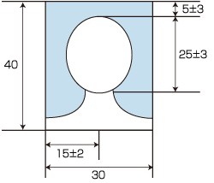

The name of the student should be printed on the back

of each photograph.