November 26, 2013

# Implementation Plan for

# Global Project Based Learning (gPBL) Course

**Prof. Hiroshi HASEGAWA**1)**, Prof. Masahiro INOUE**1)**, Prof. Kazunori MANO**1)**,**

**Prof. Atsuko YAMAZAKI**1)**, Prof. Yoshimi FURUKAWA**1)**, Dr. Masahiko TACHIBANA**1)

**Prof. Anak KHANTACHAWANA**2)

*gPBL project team*

*1) Shibaura Institute of Technology (SIT)*

*2) King Mongkut's University of Technology Thonburi (KMUTT)*

Summary:

Successful students in this course will acquire integrated capacity of problem-solving, which is required when they work as a member of an international and/or interdisciplinary team, through integrated problem solving experience in gPBL course, whereby students would be triggered by setting their own theme selected from suggested keywords by the lecturers, then exposed to hands-on experience on “Systems thinking”, “Systems Method”, and “Systems Management”.

Time: Fri, February 13, 2014 – Sun, February 23, 2014.

Venue: King Mongkut’s University of Technology, Thonburi.(KMUTT)

Participants*: 30 students from Shibaura Institute of Technology, 30 students from KMUTT

5 students from South East Asian Technical University (SEATUC)

* Both sides should be composed of 1st year students of Graduate School, Year 4 and Year 3 of undergraduate students.

Requirements: Majority of the participants should be graduate students. They will communicate with their counterparts using various devices and services, such as electronic dictionaries, smartphones and the Internet which can be utilized as a convenient knowledge base including Wikipedia, whereby the students will feel the necessity of communication in English, get an opportunity to speak in English, and become prepared for it.

1. **Forming up a team / Role of Teaching Assistants and Lecturers**

Forming up a team:

* Total of 10 teams of 6 students. Each team is made up of 3 students from SIT and 3 students from KMUTT and South East Asian Technical University.
* An ice-breaking activity is conducted on the first day, when the teams are formed.

Role of Teaching Assistants:

* 6 students; 4 from SIT and 2 from KMUTT.
* Their role is to advise the participants, to coordinate with the local staffs, and to support the management of teams.

Role of Lecturers:

* Act as an assumed investor to the project
* They make various kinds of comments and suggestions in the design review. In the design review, comments from various points of view among lecturers are allowed.
* 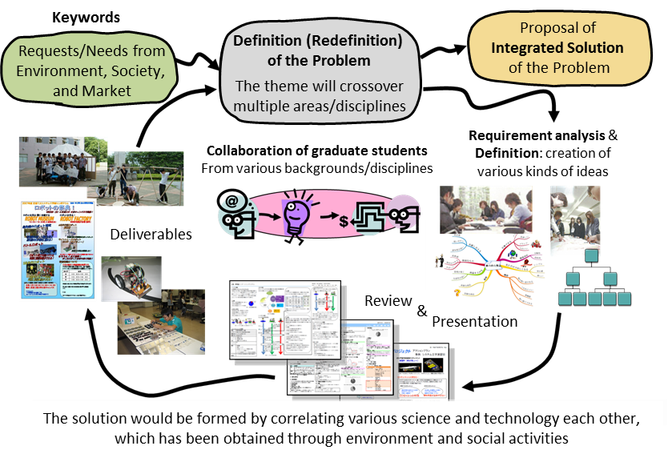Lecturers’ basic stance is to pay respect to students’ ideas and opinions; The lecturers should not force the students to follow their comments.

Figure 1. Practical Process

1. **Theme of the Project**

Some keywords, which should be referred for setting the theme, are suggested before the session starts. Students are expected not only to make a plan but also make a design implementation and a fieldwork all through the course.

1. **Schedule**

In gPBL, unexpected troubles, which people meet with very frequently in the real world, will be induced by intention. This “Oh my God” experience should trigger the improvement of competency. Each team will be requested to reconstruct the process of solving the problems by rescheduling.

Table 3.1 Tentative Schedule

|  |  |  |
| --- | --- | --- |
| (Feb 13) | Arrival | Check in KMUTT dormitory |
| Day 1 (Feb 14) | 10:00 – 17:00 | Icebreaking and forming up a team  Confirmation of the theme, requirement analysis, and goal setting |
| Day 2 (Feb 15) | 10:00 – 17:00 | Requirement analysis, goal setting, and planning, |
| Day 3 (Feb 16) | 10:00 – 17:00 | schedule Assessment planning, Budget planning and preparation of design review (DR) materials |
| Day 4 (Feb 17) | 10:00 – 17:00 | Industrial Tour (Honda Motor or Ajinomoto)  Design review |
| Day 5 (Feb18) | 10:00 – 17:00  17:00 – 19:00 | Activities in accordance with the planned schedule  (International cultural exchange) |
| Day 6 (Feb19 ) | 10:00 – 17:00 | Activities in accordance with the planned schedule |
| Day 7 (Feb20 ) | 10:00 – 17:00 | Trip to Suburban of Bangkok  Preparation of the final presentation materials.  Outcomes Assessment (PROG test, Rubric) |
| Day 8 (Feb21) | 10:00 –17:00 | Return to Bangkok, Final presentation, |
| Day 9 (Feb 22) | Departure | Check out dormitory, City Tour, Departure |
| (Feb23) |  |  |

1. **Material to be presented in Design Review (“A3 Material”)**

The A3 Material should include following points. This is the only material to be prepared for Design Review in gPBL.

1. Background and Objective
2. Requirement Analysis
   1. Present Status and the Needs, Objective Analaysis
   2. Requirements, Strategy, and Goal
   3. Assessment Plan
3. Implementation
   1. Summary and Scope
   2. Implementation Plan
4. Evaluation
   1. Evaluation Method
   2. Evaluation Result
5. Conclusion

Title

Group ID, Date

Member List

1. Background and Objective
2. Present Status and Requirements
3. Strategy and Goal

8. Implementation Schedule

- Milestone

1. Summary and Scope
   1. Requirements
   2. Evaluation Methods
2. Implementation Plan
3. Evaluation
4. Conclusion

Figure 2. A Layout Plan for “A3 Material”

1. **Standard of Evaluation for Design Review and Final Presentation**
   1. Standard of Evaluation for Design Review

In Design Review, evaluation is made with scale from 1 to 5, by using the standards (1) through (6) shown below. The actual evaluation will be conducted in three levels consecutively; (a) Evaluation by students within the same group, (b) Evaluation by students among groups, (c) Evaluation by the lecturers.

1. What are the requirements for the theme?
   * Are Background and Objective stated clearly?
   * Are Present Status and Needs analyzed well?
2. What is the goal to meet the requirements?
   * Are any ideas and proposals clearly described to reach the goal?
3. Was the relationship between Requirements and Goal an appropriate one?
4. Was the Evaluation Method planned properly?
5. Was the Budget Plan planned properly?
6. Did the resource and the oral presentation help your understanding?
   1. Standard of Evaluation for the Deliverable of the Project

The Deliverables are evaluated with scale from 1 to 5, based on the following evaluation standards.

1. Creativity: Did the group obtain creative results?
2. Applicability: Did the group obtain results that hit the point of the theme, which is applicable in general or global problems?
3. Completion: Did the group obtain results with higher degree of completion through analysis, plan, and evaluation?
4. Feasibility: Did the group set a goal with an adequate level of feasibility?
5. Achievement to the Goal: Did the group achieve the goal that was set at the beginning?
6. **Evaluation on Learning Outcomes**

Evaluation on Learning Outcomes is made after the gPBL course was completed.

1. Systems thinking. Successful learners are able to;
   * understand the process of systems engineering, where they can integrate various fields of study in interdisciplinary manner, derive an integrated solution, and evaluate the solution.
   * find the problem, analyze its requirements, make a plan for the solution for the problem, evaluate alternative solutions, and make a decision.
2. Systems management. Successful learners are able to;
   * manage and integrate human resource, knowledge, and skill for problem solving.
   * complete the project by making a plan to reach the goal, conducting the plan to fulfill the project scope, scheduling and costs, cooperating with team members as well as using their knowledge and skills.
3. International and interdisciplinary action. Successful learners are able to;
   * communicate with people who work in various kinds of fields
   * recognize a variety of languages and cultures in communication
   * act cooperatively as a team member
4. Systems design. Successful learners are able to;
   * work out a design of a system or a process that satisfies needs under various kinds of restrictions.
   * work out a specification of a system or a process satisfies the needs under various kinds of restrictions.
5. Leadership. Successful learners are able to take leadership in accordance with a given situation by judging situation properly.
6. Report in Writing and Oral Presentation. Successful learners are able to;
   * write an appropriate report, so that the readers from different cultures or languages can understand it.
   * make an appropriate report in an oral presentation, so that the listeners from different cultures or languages can understand it.

- End of the Document -