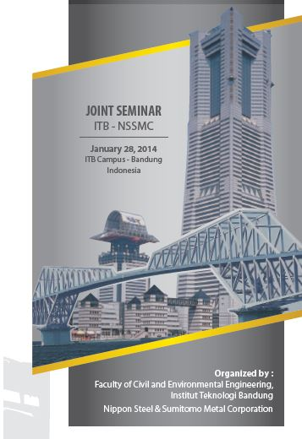
JOINT SEMINAR ITB – NSSMC
STEEL STRUCTURES:
“CHALLENGES FOR DISASTER PREVENTION AND ENGINEERING TOWARD THE FUTURE”

REGISTRATION FORM

Full Name
Institution/Company
Address
City
ZIP Code

Telephone/Cellphone Number
Email

NOTE:
Please fill this registration form and pay the registration fee to this following bank transfer account:

Bank BNI Cabang Perguruan Tinggi Bandung
Acc No. 0223 793 109
on behalf Widya Indah Susanti

Please send the completed form AND the copy of transfer receipt to via email or facsimile to the following address:

Secretariat of ITB-NSSMC Joint Seminar
Faculty of Civil and Environmental Engineering
Institut Teknologi Bandung – Indonesia
Contact phone : 085794155410, 0817223669
Fax : +62 22 – 251 2403
Email : steelseminar@itb.ac.id

