**UK-Indonesia Research Links Workshop**

**Call for Participation**

Workshop Title: Towards sustainable building and infrastructure in Indonesia

UK coordinator: Dr Robby Soetanto

Indonesia coordinator: Dr Dewi Larazati

Discipline: building, Infrastructure, construction, civil engineering

**Dates and venue: 24-27 March 2014, Bandung - Indonesia**

The British Council has launched a new five-year programme to encourage international research collaboration between ambitious young researchers from the UK and eighteen countries around the world.

The programme, ‘British Council Researcher Links’ provides opportunities for early career researchers from the UK and internationally to interact, learn from each other and explore opportunities for building long-lasting research collaborations.

As part of this programme, a ‘call to action’ was issued in June 2013 for leading researchers to propose themes for bilateral workshops to be held in one of these countries which will bring together early career researchers to discuss their research and start to build international relationships.

Successful applicant organisations from the UK and Indonesia are now recruiting early career researchers and welcome applications to attend the above workshop.

The workshops will provide a unique opportunity for sharing research expertise and networking. During the workshops early career researchers will have the opportunity to present their research in the form of a poster and short oral presentation and discuss this with established researchers from the UK and partner countries. There will be a focus on building up links for future collaborations and participants selected on the basis of their research potential and ability to build longer term links.

The British Council will cover the costs related to the participation to the workshop, including: travel (both international and local, economy class), accommodation and meals. The costs for postal visa application will be covered; however participants will be responsible for making all the necessary arrangements. Although this cost will not be covered by the British Council, participants are encouraged to purchase adequate travel and medical insurance. The British Council accepts no responsibility for any problems which may occur when the participants are in the host country.

**Application and Deadline:**

The full application below must be completed and submitted by **Friday 20 December 2013** to:

Dr Robby Soetanto (via [R.Soetanto@lboro.ac.uk](mailto:R.Soetanto@lboro.ac.uk)) for UK applicants, or

Dr Dewi Larazati (via [dewizr_ar@yahoo.com](mailto:dewizr_ar@yahoo.com)) for Indonesia applicants

**Eligibility Criteria:**

* Applications must be submitted using the Researcher Links application form (available in the next two pages)
* Application must be submitted before the above deadline

Participants must be early career researchers: Early career researchers are defined as holding a PhD (or having equivalent research experience, e.g. significant roles on funded research projects) and having up to 10 years post-PhD research experience. They are equivalent to the ‘Recognised Researcher’ and sometimes ‘Established Researcher’ categories in the EU framework for researchers’ careers[1]. ‘Leading Researchers’ as defined by the EU Framework for researchers careers are research group leaders who are internationally recognised in their field.

Participants must have a research or academic position (either a permanent post, research contract, or fellowship etc.) at a recognised research institution either in the UK or in Indonesia.

**Quality Assessment**

* Experience and relevance of the applicant’s research area to the workshop
* Motivation and contribution to the aims of the workshop
* Description of the long term impact expected through the participation in the workshop
* Ability to disseminate workshop’s outcomes
* Demonstrable experience and/or interest in problems encountered by developing economies
* Demonstrable experience and/or willingness to work in a creative, multi-disciplinary collaboration context.

**Selection Procedure:**

* Eligibility check
* Quality assessment

**Applications to this call carry a commitment to:**

* attend and actively participate in the workshop from **24 to 27 March 2014** in Indonesia
* attend a half-day induction/preparatory event at Loughborough University (for UK participants) or Institut Teknologi Bandung (for Indonesia participants) on **Thursday 20 February 2014,** afternoon only. Please note that travel is unfortunately not funded for this event
* produce materials for presenting their own expertise and research area during the workshop (for example, research poster)

**Notification of results:**

Successful applicants will be notified by email 2 months prior to the workshop.

**Equal Opportunities**

The British Council is committed to equal opportunities and diversity in all its activities and this includes the avoidance of any bias in the assessment of applications due to gender, disability, racial or ethnic origin, sexual orientation, or religious belief. Participants’ selection undertaken by workshop organisers must not contravene this policy. Extra support to enable participation of early career researchers with special needs will be given.

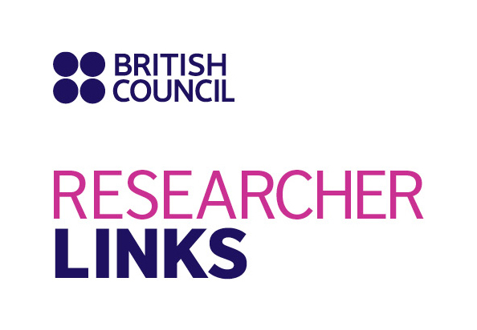

Application Form

|  |  |
| --- | --- |
| **1. Applicant** | |
| Name and title |  |
| Gender (to monitor statistic participation – this will not be considered during assessment) |  |
| Position and institution |  |
| Postal address |  |
| Email |  |
| Phone number |  |
| Brief CV (academic career, publications, markers of esteem, and any other relevant information) – **no more than 300 words** |  |

|  |
| --- |
| **Abstract - Please give a summary of your area of research and explain how this is relevant and will contribute to the workshop (no more than 300 words)** |
|  |

|  |
| --- |
| **3. Please describe your motivation to attend the workshop and how the workshop matches your professional development needs (no more than 200 words)** |
|  |

|  |
| --- |
| **4. Please describe the expected impact of your participation to the workshop on your personal and professional development, including your ability to work on an international level (no more than 200 words)** |
|  |

|  |
| --- |
| **5. Please indicate how you will disseminate the outcomes of the workshops and the new knowledge/skills you have acquired (no more than 200 words)** |
|  |

|  |  |  |  |
| --- | --- | --- | --- |
| **6. Workshops will take place in English as standard. Please indicate your ability to work and communicate in English** **(Note, translators will not be provided)** | | | |
| Native speaker |  | Good |  |
| Excellent |  | Need support |  |

|  |
| --- |
| **7. Please use this space to give any additional information that you feel is relevant for the application (no more than 300 words)** |
|  |

1. <http://ec.europa.eu/euraxess/pdf/research_policies/Towards_a_European_Framework_for_Research_Careers_final.pdf>